Last Name: First Name: Student ID:

Q1.

a) [7 pts] SQL Query:



b) [3 pts] Result: (8 Rows)



Q2.

a) [7 pts] SQL Query:



b) [3 pts] Result: (3 Rows)



Q3.

a) [7 pts] SQL Query:



b) [3 pts] Result: (1 Row)



Q4. [20 pts]

a) [10pts] Create view statement:



b) [10 pts] SQL query:

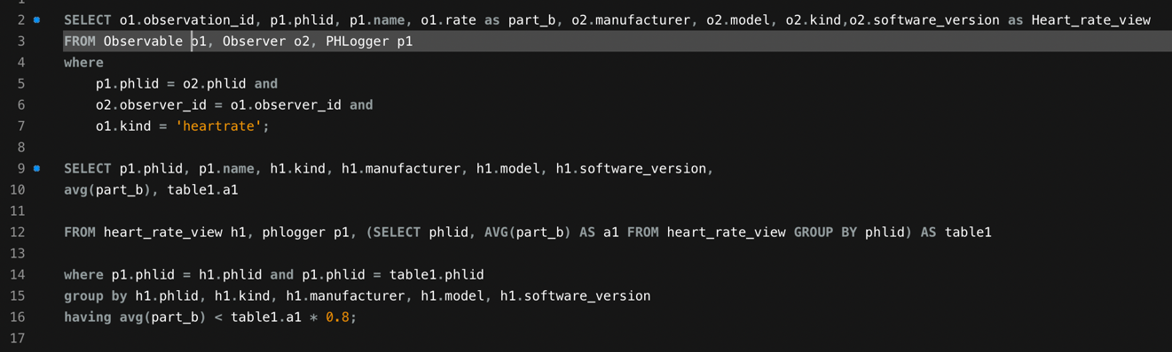

Result: (3 rows)



Q 5. Stored Procedures [20 pts]

a) [15pts] Create procedure statement:

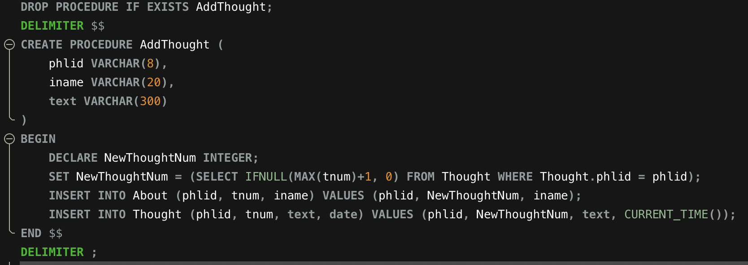

b) [5 pts] Result:



Q 6. Alter Table[10 pts]

a) [5 pts] Alter table statement:



b) [5 pts] Result:



Q7. Triggers [20 pts]

a) [5pts] Create trigger statement:



b) [10 pts] Create trigger statement:

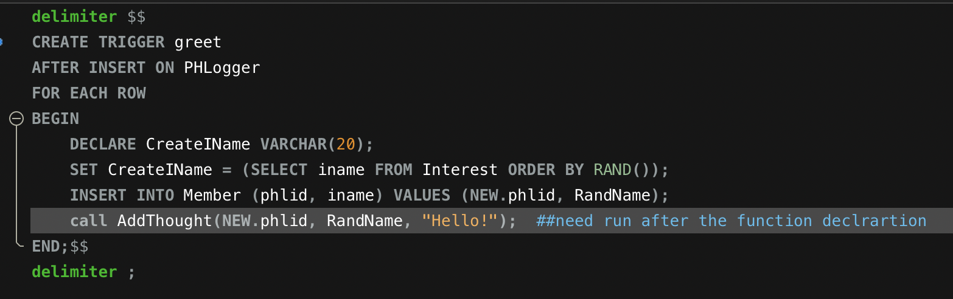

c) [5 pts] Result:

